**MAKERERE  UNIVERSITY**

**COLLEGE OF COMPUTING AND INFORMATION SCIENCES**

**(YEAR II) RECESS TERM**

**SOFTWARE REQUIREMNETS SPECIFICATION DOCUMENT**

**DIABETES PREDICTION MODEL**

**PROJECT MEMBERS**

|  |  |  |
| --- | --- | --- |
| **NAME** | **REGISTRATION NUMBER** | **STUDENT NUMBER** |
| Kabahinda Rovence | 17/U/4261/PS | 217003233 |
| Meleby Nyika Jino | 17/x/18244/PS | 217019537 |
| Arikosi Michael Okurut | 17/U/2900/PS | 217004064 |
| Mwanje Mike | 17/U/6856/PS | 217004074 |

**PROJECT COORDINATOR**: MR. KAMULEGEYA GRACE

**SOFTWARE REQUIREMENTS SPECIFICATION**

**INTRODUCTION**

This is the description of the whole kidney_disease.csv dataset pipeline, who the intended users are, what they will use the pipeline for and use case diagrams that describe the interactions the pipeline must provide to different users of the system.

**INTENDED USERS OF THE DATA PIPELINE**

The intended users of this document and pipeline include:

* System admin
* Users(student, medical personnel, supervisor)

**USE OF THE PIPELINE TO DIFFERENT USERS.**

*SYSTEM ADMIN*

* He/ She will use the pipeline to fine tune the system parameters, train the model and address any errors to ensure the different users have a smooth interaction with the system.

*USERS*

* *Student –* will use the data pipeline to gain a proper understanding of the data science concepts undertaken to accomplish the diabetes detection task.
* *Medical personnel –* will use the data pipeline to understand how the model will use the provided features to determine if a person has diabetes or not.
* *Supervisor –* will use the data pipeline to verify if the model was created in the right way to attain the best results as a way of assessing the student.

**USE CASE DIAGRAMS FOR THE PIPELINE**

1. USER

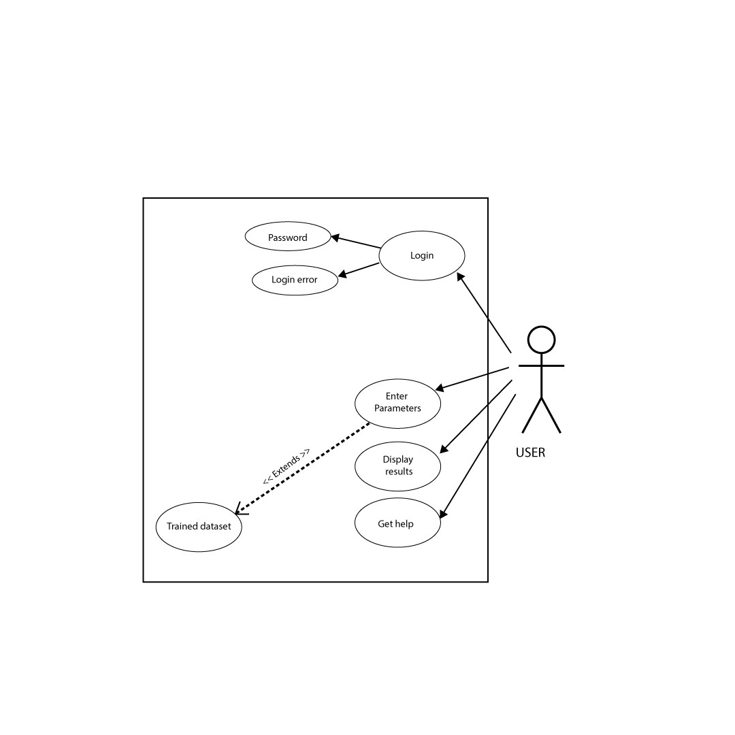

DESCRIPTION

* The user requests login in to the system.
* The user credentials are verified before login. If credentials are correct, the user successfully accesses the system. If not the, the login error message is displayed.
* The user can enter required parameters like blood glucose levels, blood pressure, blood urea, and sugar levels to be used by analyzed by the model
* The parameters are passed to the trained dataset for analysis.
* The results are output are then displayed to the user
* The user can request for help on how to user the model and instruction are returned accordingly.

1. SYSTEM ADMINISTRATOR

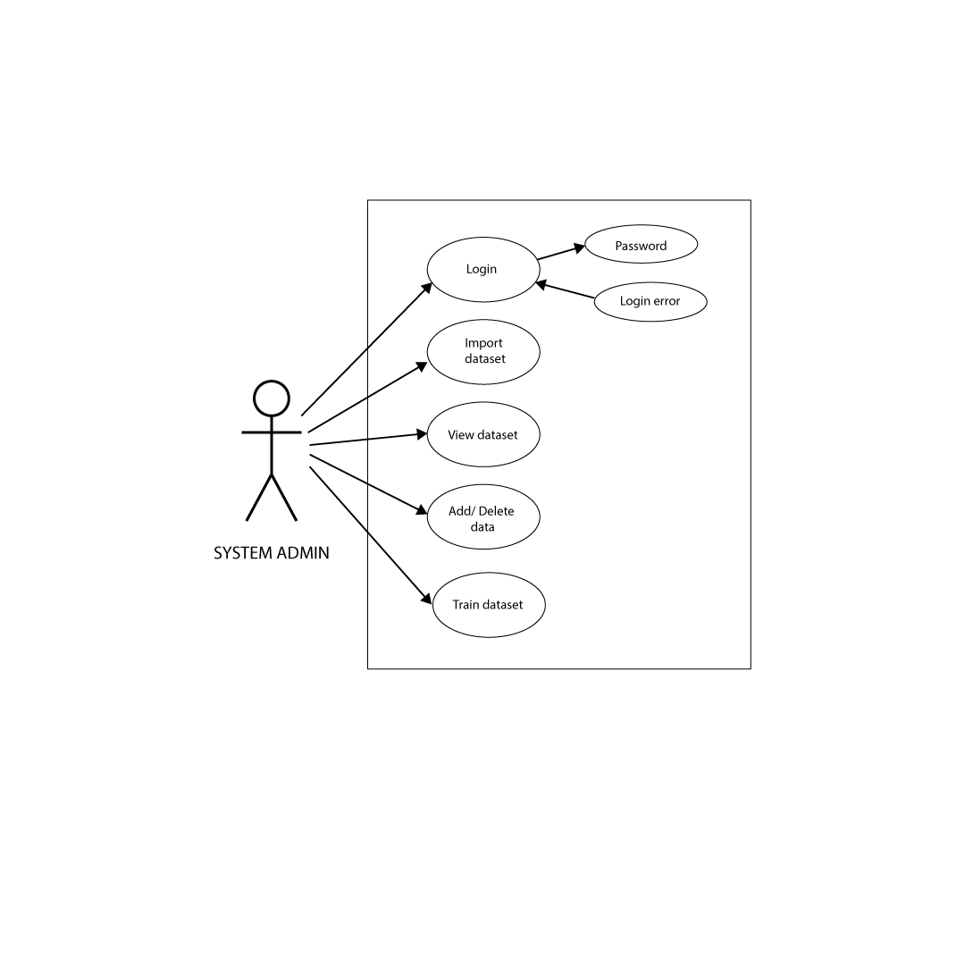

DESCRIPTION

* The user requests login in to the system.
* The user credentials are verified before login. If credentials are correct, the user successfully accesses the system. If not the, the login error message is displayed.
* The systems admin imports the dataset compatible with the model
* The data in the dataset can then be viewed by the user.
* The system admin can add new rows to the dataset, delete rows from the dataset and modify existing data in the dataset.
* The admin can then use the data in the dataset to train the predictive analysis model.

REFERENCES:

1. [https://archive.ics.uci.edu/ml/datasets/chronic_kidney_disease#](https://archive.ics.uci.edu/ml/datasets/chronic_kidney_disease)